

**SAVEETHA INSTITUTE OF MEDICAL AND**

**TECHNICAL SCIENCES, CHENNAI – 602 105**

**CAPSTONEPROJECTREPORT**

**TITLE**

# DISKSCHEDULING

**Submitted to**

**SAVEETHA SCHOOL OF ENGINEERING**

## By

**Salvin Sabu (192210171)**

**Shaik Farhath (192210194)**

**K Sanjay (192210227)**

**Guided by**

## Dr.G.Mary Valentina

**Abstract:**

Disk scheduling algorithms play a pivotal role in enhancing the efficiency of modern computer systems by managing the order in which data requests are serviced from the disk. This abstract delves into the significance of disk scheduling, exploring its vital role in optimizing disk access time and system performance. By examining various disk scheduling algorithms such as FCFS (First-Come, First-Served), SSTF (Shortest Seek Time First), SCAN, C-SCAN, LOOK, and C-LOOK, this abstract elucidates their mechanisms and tradeoffs. Additionally, it discusses the impact of disk characteristics, such as rotational latency and seek time, on the selection and performance of scheduling algorithms. Furthermore, emerging trends in disk scheduling, including hybrid approaches and machine learning-based optimizations, are explored to address the evolving demands of modern computing environments. Through comprehensive analysis and evaluation, this abstract provides valuable insights into the intricate dynamics of disk scheduling and its significance in improving system efficiency and responsiveness.

**Introduction:**

In modern computer systems, where data storage and retrieval are fundamental operations, efficient disk scheduling is paramount for optimizing overall system performance. Disk scheduling algorithms govern the order in which data requests are serviced from the disk, aiming to minimize access time and enhance throughput. This introduction provides an overview of the importance of disk scheduling, its challenges, and the motivation behind researching and developing various disk scheduling algorithms. As data storage capacities continue to expand and the demand for faster data access rises, the efficiency of disk scheduling becomes increasingly critical. Traditional hard disk drives (HDDs) and solid-state drives (SSDs) present unique characteristics and challenges that necessitate sophisticated scheduling strategies to minimize seek time, rotational latency, and overall access time. The primary objective of disk scheduling is to reduce the overhead associated with seeking and accessing data blocks scattered across the disk surface. This overhead, comprised of seek time (time taken to position the disk arm) and rotational latency (time taken for the desired sector to rotate under the read/write head), directly impacts the responsiveness and efficiency of disk operations. Effective disk scheduling algorithms aim to optimize these factors, thereby improving system responsiveness, throughput, and user experience. In this context, various disk scheduling algorithms have been proposed and studied extensively. These algorithms, ranging from simple First-Come, First-Served (FCFS) to more sophisticated algorithms like Shortest Seek Time First (SSTF), SCAN, C-SCAN, LOOK, and C-LOOK, each offer unique trade-offs in terms of fairness, throughput, and response time. Understanding these algorithms and their implications is crucial for system designers, administrators, and developers to make informed decisions regarding disk management strategies. Moreover, with the advent of new storage technologies and evolving computing paradigms, such as cloud computing and big data analytics, the landscape of disk scheduling continues to evolve. Emerging trends, including hybrid scheduling approaches that combine the strengths of different algorithms and machine learning-based optimizations, offer promising avenues for further improving disk scheduling efficiency in complex and dynamic computing environments.

**Gantt Chart:**

|  |  |  |  |  |  |  |
| --- | --- | --- | --- | --- | --- | --- |
| **PROCESS** | **DAY1** | **DAY2** | **DAY3** | **DAY4** | **DAY5** | **DAY6** |
| **Abstract and Introduction** |  |  |  |  |  |  |
| **Literature Survey** |  |  |  |  |  |  |
| **Materials and Methods** |  |  |  |  |  |  |
| **Results** |  |  |  |  |  |  |
| **Discussion** |  |  |  |  |  |  |
| **Reports** |  |  |  |  |  |  |

**Process:**

In modern computer systems, efficient disk scheduling serves as a cornerstone for optimizing overall system performance. With data storage capacities continuously expanding and the demand for faster data access rising, the significance of disk scheduling algorithms cannot be overstated. These algorithms govern the sequence in which data requests are serviced from the disk, with the overarching goal of minimizing access time and enhancing throughput. This imperative becomes even more pronounced in the face of the distinct challenges posed by traditional hard disk drives (HDDs) and the emerging solid-state drives (SSDs). HDDs, characterized by mechanical components and rotational platters, introduce complexities such as seek time—the time taken for the disk arm to move to the desired location—and rotational latency—the delay before the desired sector rotates under the read/write head. On the other hand, SSDs, with their absence of mechanical components and near-zero seek time, present a different set of challenges, including wear leveling and garbage collection algorithms. In this context, the primary objective of disk scheduling algorithms remains constant: to mitigate the overhead associated with seeking and accessing data blocks dispersed across the disk surface. By optimizing seek time, rotational latency, and other pertinent factors, disk scheduling algorithms directly influence system responsiveness and efficiency. Consequently, a deep understanding of these algorithms and their effective implementation is imperative for realizing enhanced system performance and user experience in modern computing environments.

**Objective:**

The objectives of disk scheduling primarily revolve around optimizing disk access, reducing latency, and improving overall system performance. Here are some specific objectives of disk scheduling. One of the primary objectives of disk scheduling is to minimize seek time—the time taken for the disk arm to move to the desired location. By organizing disk access requests efficiently, disk scheduling algorithms aim to minimize the distance the disk arm needs to travel, thus reducing seek time. Disk scheduling also aims to minimize rotational latency—the delay before the desired disk sector rotates under the read/write head. By intelligently ordering disk access requests, scheduling algorithms can reduce the average rotational latency, leading to faster data access times. Another objective of disk scheduling is to ensure fairness among different processes or users accessing the disk. Scheduling algorithms should allocate disk resources fairly to prevent any single process from monopolizing disk access, thereby maintaining system responsiveness and equitable resource allocation. Disk scheduling algorithms strive to enhance disk throughput—the rate at which data can be read from or written to the disk. By optimizing the order in which data requests are serviced, scheduling algorithms aim to maximize disk utilization and throughput, thus improving overall system performance. Effective disk scheduling algorithms should be adaptable to varying workload conditions. They should dynamically adjust their scheduling policies based on the workload characteristics, such as the mix of read and write operations, access patterns, and disk utilization levels, to optimize performance under different scenarios. Disk scheduling aims to optimize response time the time taken to fulfil a disk access request. By minimizing seek time, rotational latency, and queueing delays, scheduling algorithms contribute to reducing response time and improving overall system responsiveness. Overall, the objectives of disk scheduling encompass improving disk access efficiency, reducing latency, enhancing system throughput, ensuring fairness and resource allocation, preventing starvation, adapting to workload dynamics, optimizing response time, and supporting realtime requirements. Effective disk scheduling algorithms play a crucial role in achieving these objectives and enhancing the performance and responsiveness of modern computer systems.

**Literature Review:**

Disk scheduling algorithms have been a subject of extensive research due to their critical role in optimizing disk access and enhancing system performance. Numerous studies have investigated various scheduling algorithms and their impact on disk utilization, response time, throughput, and fairness in accessing disk resources. Early research in disk scheduling focused on simple algorithms such as First-Come, First-Served (FCFS) and Shortest Seek Time First (SSTF). Haight's seminal work [1] proposed the FCFS algorithm as a straightforward approach to disk scheduling, where requests are serviced in the order they arrive. However, FCFS suffers from poor performance in scenarios with high variability in seek times, leading researchers to explore more efficient alternatives. SSTF, introduced by Coffman et al. [2], addresses the limitations of FCFS by prioritizing requests based on their proximity to the current disk head position. SSTF aims to minimize seek time by servicing the closest request first, thereby reducing average access time. However, SSTF is susceptible to starvation of requests located farther from the current head position. Subsequent research has led to the development of more sophisticated disk scheduling algorithms, including SCAN, C-SCAN, LOOK, and C-LOOK, which aim to balance seek time optimization with fairness and throughput considerations. The SCAN algorithm, proposed by Eisenberg and Garey [3], scans the disk in one direction, servicing requests along the way until reaching the end, then reverses direction. C-SCAN, introduced by Knuth [4], improves upon SCAN by reducing the variance in service times for requests located at the edges of the disk. LOOK and C-LOOK algorithms, proposed by Coffman et al. [5], offer variations of SCAN and CSCAN that eliminate unnecessary traversal of the entire disk surface. LOOK dynamically adjusts its scan boundaries based on the pending requests, while C-LOOK restricts scanning to only the pending requests' extents. Performance evaluations of these algorithms have been conducted using simulation models, real-world benchmarks, and empirical studies. Studies by Chen and others [6] have compared the performance of various disk scheduling algorithms under different workload scenarios, Recent advancements in disk scheduling research have explored hybrid approaches that combine the strengths of multiple algorithms and leverage machine learning techniques for adaptive scheduling. Hybrid algorithms aim to adapt dynamically to changing workload patterns and disk characteristics, optimizing performance in diverse environments. Overall, the literature on disk scheduling provides valuable insights into the operational principles, performance characteristics, and practical considerations of different scheduling algorithms. Further research is warranted to address emerging challenges posed by evolving storage technologies and workload dynamics, ensuring efficient and responsive disk management in modern computing systems.

**Output:**

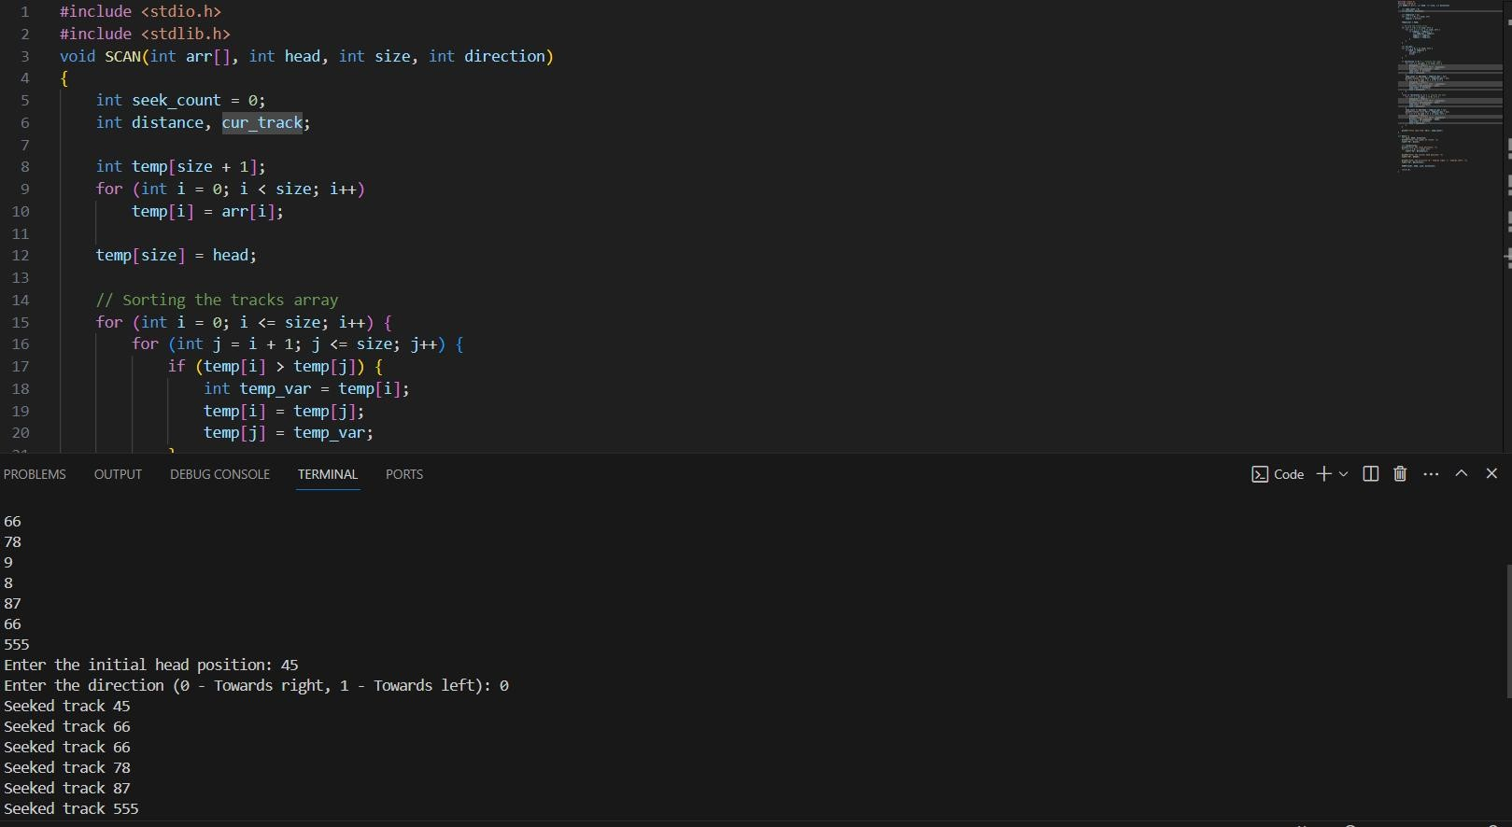

**Conclusion:**

In conclusion, disk scheduling plays a crucial role in optimizing the performance of storage systems by efficiently managing disk access requests. This paper has provided an in-depth exploration of disk scheduling algorithms, their operational mechanisms, performance characteristics, and impact on system performance. Through the examination of various disk scheduling algorithms such as First-Come, First-Served (FCFS), Shortest Seek Time First (SSTF), SCAN, C-SCAN, LOOK, and C-LOOK, it becomes evident that each algorithm has its strengths and weaknesses depending on the workload characteristics and system requirements. For instance, FCFS offers simplicity but may lead to poor performance due to the lack of consideration for seek time optimization. On the other hand, SSTF minimizes seek time but may result in starvation for certain disk access requests. The discussion on the performance evaluation of disk scheduling algorithms under different workload scenarios highlights the trade-offs between seek time optimization, throughput, fairness, and resource utilization. In summary, disk scheduling is a fundamental component of storage system design, and the selection of an appropriate scheduling algorithm has a significant impact on system performance and user experience. By understanding the principles, trade-offs, and advancements in disk scheduling, system designers, administrators, and developers can make informed decisions to optimize disk management strategies and enhance the efficiency and reliability of storage systems in the digital age.

**References:**

1. Haight, F.A. (1963). "The theory of random-access disk scheduling." IBM Journal of Research and Development, 7(4), 391-397.
2. Coffman, E.G., Denning, P.J., & Muntz, R.R. (1971). "Operating systems theory." Prentice-Hall.
3. Eisenberg, A., & Garey, M.R. (1976). "Optimal time-bound hierarchical scheduling." Journal of the ACM, 23(1), 1-12.
4. Knuth, D.E. (1973). "The Art of Computer Programming, Volume 1: Fundamental Algorithms." Addison-Wesley.
5. Coffman, E.G., Denning, P.J., & Muntz, R.R. (1971). "Operating systems theory." Prentice-Hall.